February 2019

Dear Parent/Carer,

Welcome to the Easter edition of our Sevenhills newsletter. The weeks have quickly passed, with many successes and positives to celebrate. In an action-packed term, pupils have built several community links within the local area, challenged themselves academically and supported their own and others wellbeing. Most recently in the last week, we have welcomed back Jenny Smith as she begins her slow transition back to work from health trouble. Jake Thompson continues in his role as head of centre until summer.

Community

In the world of business Electric Thizzle represented Sevenhills in the local round of the Young Enterprise competition. The three young ladies were a credit to themselves and the academy. Presenting to a large audience is never easy, but they spoke with confidence and charisma that captivated the room and impressed the judges. Following a long deliberation Electric Thizzle were just piped to the post by fellow Wellspring Team Ezee Lights representing Park. Both teams now go forward to the regional finals in May.
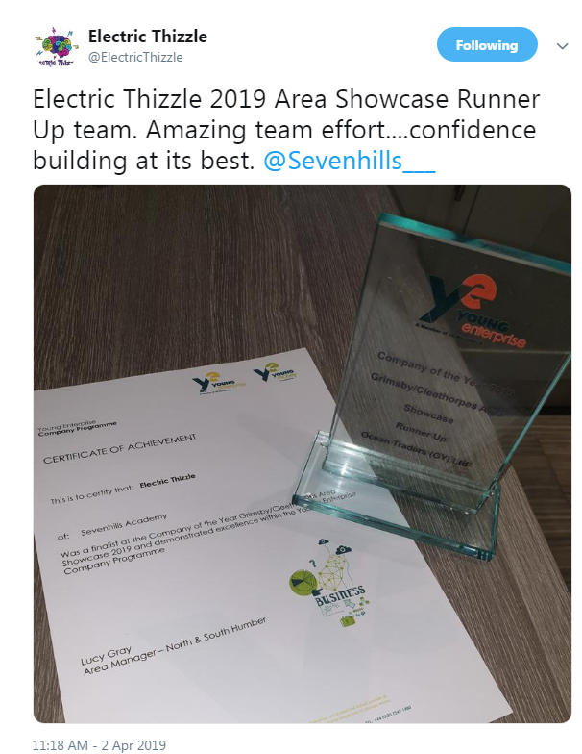
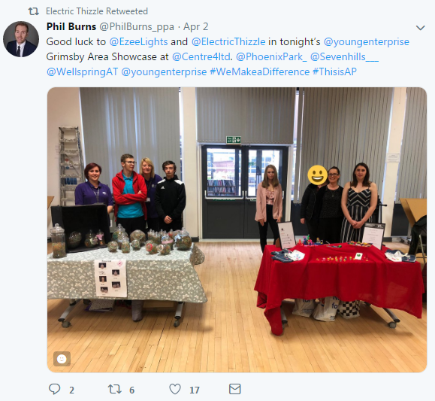
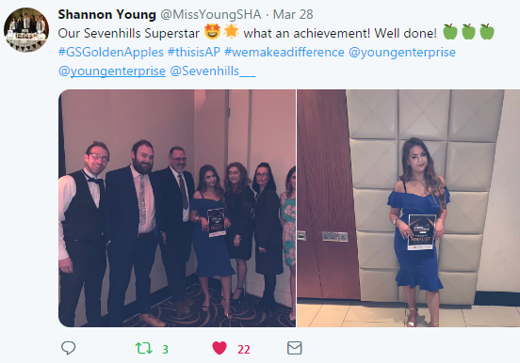
One of the superstars of last year’s young enterprise team continued to impress and gain recognition for her achievements was Chloe. She was shortlisted as a finalist for the Golden Apple awards for overcoming challenge. Chloe should be extremely proud, and you are a winner in our eyes. Proving that you can achieve anything with hard work and dedication. Remember this as you move on to your next chapter.

Tutor groups continued to support their local charities and organisations. Pupils organised several activities to support extremely good causes. Humber 8 delivered Easter treats to Women’s Aid. Thames 6 made Easter cards for the children at St Andrews Hospice. Balmoral 4 organised a charity football match with Humberside police. Throughout these activities’ pupils recognised the importance of helping others. Very impressive work!
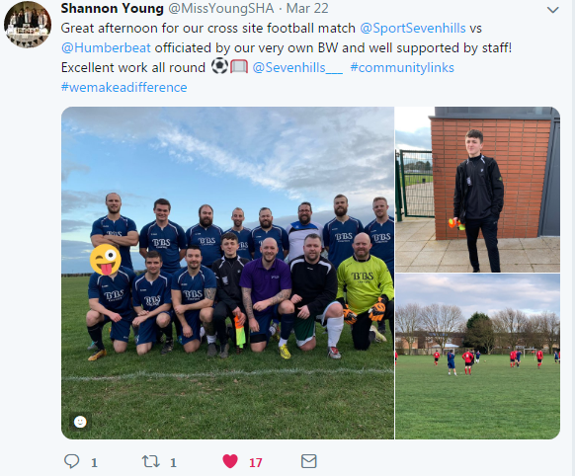
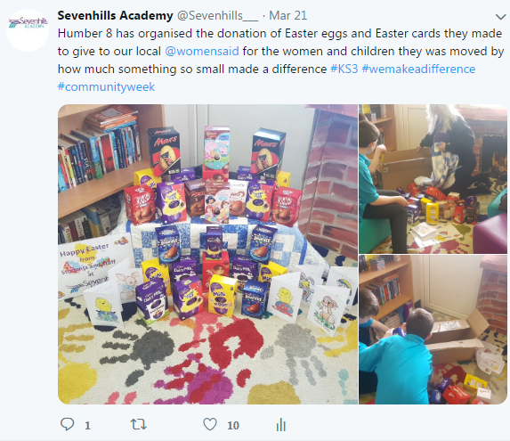

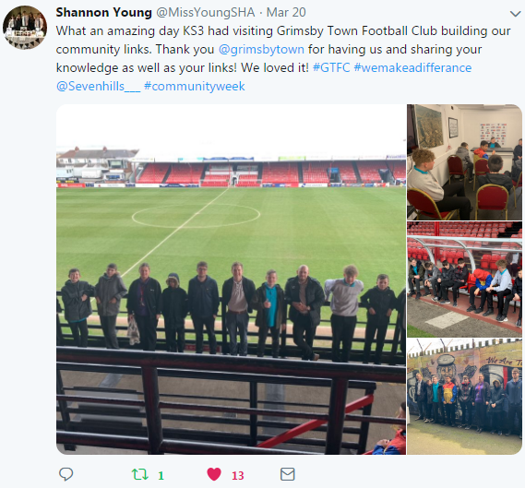
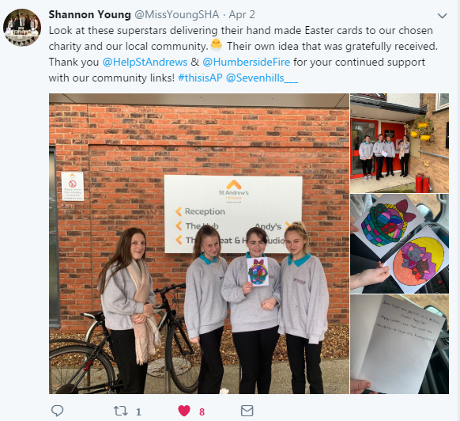

Learning Celebrations
Throughout the term students have been encouraged to challenge themselves and apply their knowledge in different concepts. At Sevenhills we take great pride in making learning enjoyable and personalised for all our students. During the spring term we hosted Wellspring colleagues for our academy review. Feedback was particularly encouraging with pupils demonstrating positive attitudes to learning and engaged throughout. We recognise there will be challenges, but we are always here to support every young person that joins us on their journey.

Here are some positive experiences captured throughout the term:
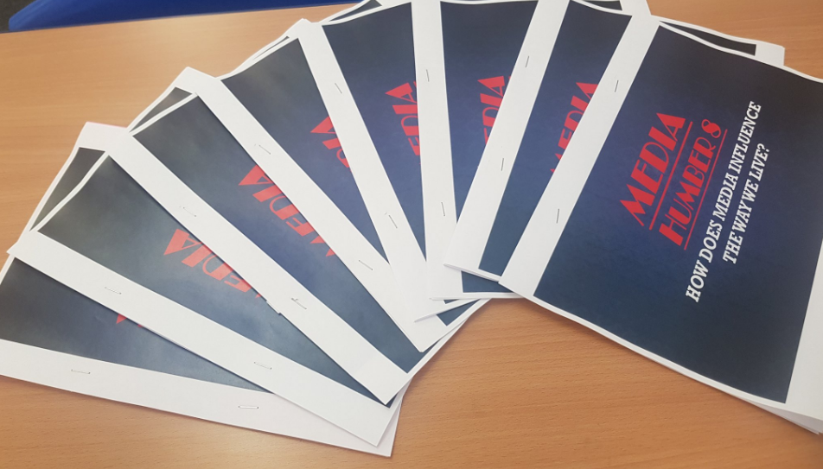
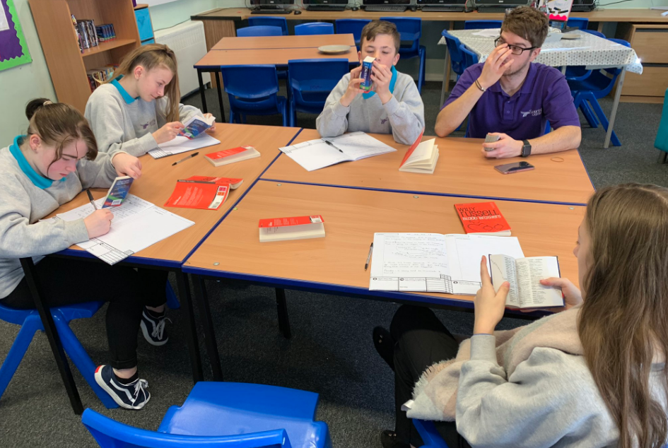

KS3 developed an informative booklet as English lessons focused on group reading,
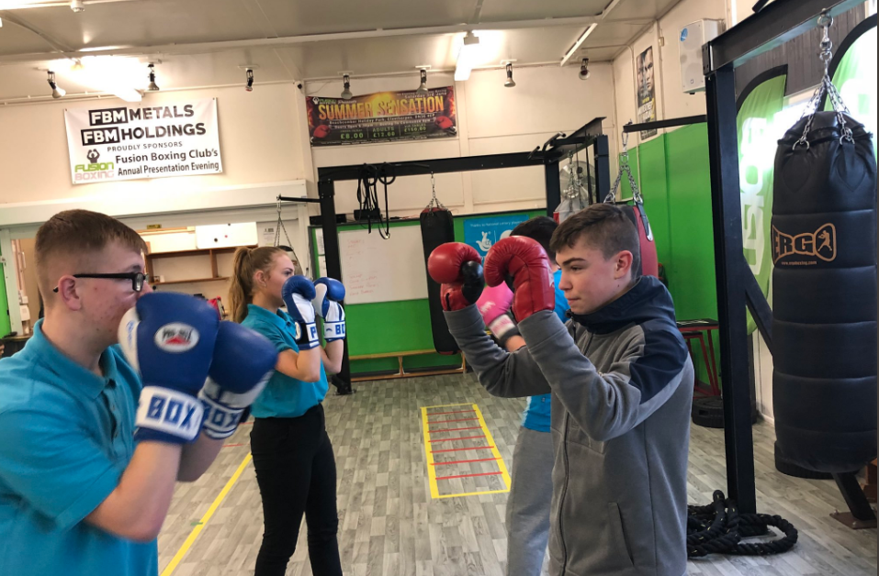
part of their media topic. covering the spirited play Blood Brothers.
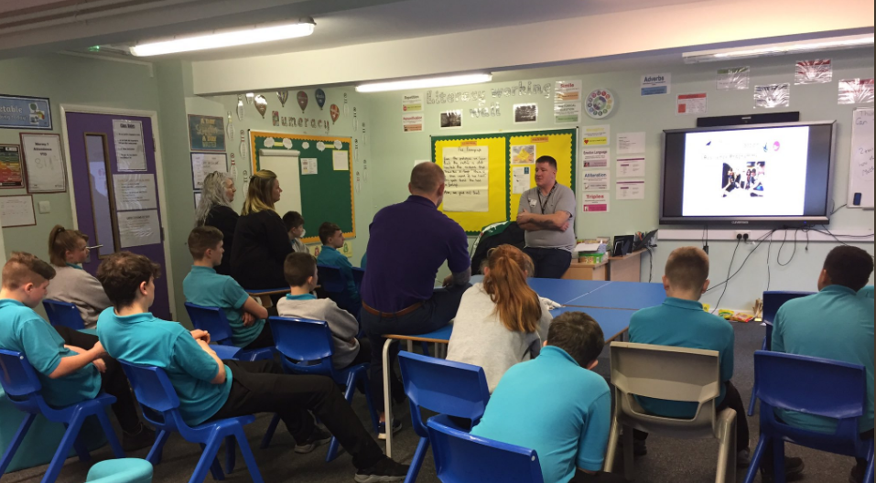

Pupils developed their teamwork skills
PSHE has covered the dangers of substance abuse, working closely with the Amy Winehouse Foundation and Addaction. We are always here to support and educate our learners.
through boxing workshops. Students have
also started to access anger management
and emotional resilience workshops.
I would like to take the opportunity to wish you all a fantastic Easter break. Next term will see several key transitions, with our year 11 cohort completing their GCSE’s and KS3 pupils taking their next steps. Our staff will always be here to support every step of the way. Take care and we look forward to greeting you in the summer term.

Kind Regards
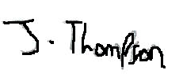

Jake Thompson

Key dates for the diary

Wednesday 24th April – Students return to school.

Sports Day – Thursday 4th July 2019

Half Term – Break up 24th May 2019 12:30pm. Return 3rd June 2019

Review Day – Monday 15th July 2019

5 week parent course, ran by Rachel Patchett – Starting Thursday 25th April 2019

